
MACHAKOS UNIVERSITY

SCHOOL OF ENGINEERING & TECHNOLOGY

DEPARTMENT OF COMPUTING & INFORMATION TECHNOLOGY

Course Programme:
BSc Computer Science and Mathematics

Course Unit:
SIT 121 Introduction to Operating Systems

Semester & Academic Year
First Year Second Semester 2020/2021

Lecturer:
Mr. Raphael Kaibiru

Copyright © Machakos University, 2021
All Rights Reserved

MONTH, YEAR
MARCH, 2021
LECTURE 5: CPU SCHEDULING
  - INTRODUCTION
CPU scheduling is the basis of multi-programmed operating systems. By switching the CPU among processes, the operating system can make the computer more productive. In this chapter, we introduce basic CPU-scheduling concepts and present several CPU-scheduling algorithms. We also consider the problem of selecting an algorithm for a particular system.
This lecture is organized as follows;
- Introduction
- Lecture objectives
- Scheduling basics
- Scheduling criteria
- Scheduling algorithms
- Algorithm evaluation
- Self-test questions
- Summary
- Reference

  - Lecture Objectives
At the end of this lecture studenst are expected to;
- Explain the basic concepts of CPU scheduling.
- Discuss scheduling criteria.
- Discuss various scheduling algorithms.
- Evaluate algorithms to determine the best.
  - Basic Concepts
In a single-processor system, only one process can run at a time. Others must wait until the CPU is free and can be rescheduled. The objective of multiprogramming is to have some process running at all times, to maximize CPU utilization. The idea is relatively simple. A process is executed until it must wait, typically for the completion of some I/O request. In a simple computer system, the CPU then just sits idle. All this waiting time is wasted; no useful work is accomplished. With multiprogramming, we try to use this time productively. Several processes are kept in memory at one time. When one process has to wait, the operating system takes the CPU away from that process and gives the CPU to another process. This pattern continues. Every time one process has to wait, another process can take over use of the CPU. Scheduling of this kind is a fundamental operating-system function. This section discusses the concepts that are key to CPU scheduling.

    - CPU-I/O Burst Cycle
The success of CPU scheduling depends on an observed property of processes: process execution consists of a cycle of CPU execution and I/O wait. Processes alternate between these two states. Process execution begins with a CPU burst.
That is followed by an I/O burst, which is followed by another CPU burst, then another I/O burst, and so on. Eventually, the final CPU burst ends with a system request to terminate execution.

    - CPU Scheduler
Whenever the CPU becomes idle, the operating system must select one of the processes in the ready queue to be executed. The selection process is carried out by the short-term scheduler, or CPU scheduler. The scheduler selects a process from the processes in memory that are ready to execute and allocates the CPU to that process.
Note that the ready queue is not necessarily a first-in, first-out (FIFO) queue. As we shall see when we consider the various scheduling algorithms, a ready queue can be implemented as a FIFO queue, a priority queue, a tree, or simply an unordered linked list. Conceptually, however, all the processes in the ready queue are lined up waiting for a chance to run on the CPU. The records in the queues are generally process control blocks (PCBs) of the processes.

    - Preemptive Scheduling
CPU-scheduling decisions may take place under the following four circumstances:
1. When a process switches from the running state to the waiting state (for example, as the result of an I/O request or an invocation of wait() for the termination of a child process).
2. When a process switches from the running state to the ready state (for example, when an interrupt occurs)
3. When a process switches from the waiting state to the ready state (for example, at completion of I/O)
4. When a process terminates.
When scheduling takes place only under circumstances 1 and 4, we say that the scheduling scheme is non-preemptive or cooperative. Otherwise, it is preemptive. Under non-preemptive scheduling, once the CPU has been allocated to a process, the process keeps the CPU until it releases the CPU either by terminating or by switching to the waiting state.
    - Dispatcher
Another component involved in the CPU-scheduling function is the dispatcher.
The dispatcher is the module that gives control of the CPU to the process selected by the short-term scheduler. This function involves the following:
• Switching context
• Switching to user mode
• Jumping to the proper location in the user program to restart that program
The dispatcher should be as fast as possible, since it is invoked during every process switch. The time it takes for the dispatcher to stop one process and start another running is known as the dispatch latency.

  - Scheduling Criteria
Different CPU-scheduling algorithms have different properties, and the choice of a particular algorithm may favor one class of processes over another. Many criteria have been suggested for comparing CPU-scheduling algorithms.
The criteria include the following:
- CPU utilization. We want to keep the CPU as busy as possible. Conceptually, CPU utilization can range from 0 to 100 percent. In a real system, it should range from 40 percent (for a lightly loaded system) to 90 percent (for a heavily loaded system).
- Throughput. If the CPU is busy executing processes, then work is being done. One measure of work is the number of processes that are completed per time unit, called throughput. For long processes, this rate may be one process per hour; for short transactions, it may be ten processes per second.
- Turnaround time. From the point of view of a particular process, the important criterion is how long it takes to execute that process. The interval from the time of submission of a process to the time of completion is the turnaround time. Turnaround time is the sum of the periods spent waiting to get into memory, waiting in the ready queue, executing on the CPU, and doing I/O.
- Waiting time. The CPU-scheduling algorithm does not affect the amount of time during which a process executes or does I/O. It affects only the amount of time that a process spends waiting in the ready queue. Waiting time is the sum of the periods spent waiting in the ready queue.
- Response time. In an interactive system, turnaround time may not be the best criterion. Often, a process can produce some output fairly early and can continue computing new results while previous results are being output to the user.

It is desirable to maximize CPU utilization and throughput and to minimize turnaround time, waiting time, and response time.

  - Scheduling Algorithms
CPU scheduling deals with the problem of deciding which of the processes in the ready queue is to be allocated the CPU. There are many different CPU-scheduling algorithms. In this section, we describe several of them.

    - First Come, First Served Scheduling
By far the simplest CPU-scheduling algorithm is the first-come, first-served
(FCFS) scheduling algorithm. With this scheme, the process that requests the CPU first is allocated the CPU first.
On the negative side, the average waiting time under the FCFS policy is often quite long. Consider the following set of processes that arrive at time 0, with the length of the CPU burst given in milliseconds:
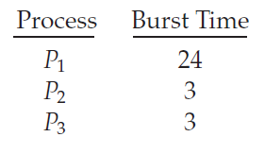
If the processes arrive in the order P1, P2, P3, and are served in FCFS order, we get the result shown in the following Gantt chart, which is a bar chart that illustrates a particular schedule, including the start and finish times of each of the participating processes:
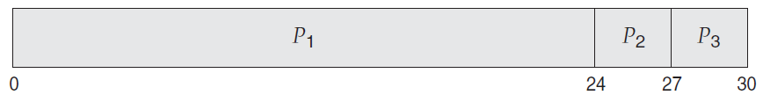
The waiting time is 0 milliseconds for process P1, 24 milliseconds for process P2, and 27 milliseconds for process P3. Thus, the average waiting time is (0 + 24 + 27)/3 = 17 milliseconds.
Note also that the FCFS scheduling algorithm is non-preemptive. Once the CPU has been allocated to a process, that process keeps the CPU until it releases the CPU, either by terminating or by requesting I/O. The FCFS algorithm is thus particularly troublesome for time-sharing systems, where it is important that each user get a share of the CPU at regular intervals. It would be disastrous to allow one process to keep the CPU for an extended period.
    - Shortest-Job-First Schedule
A different approach to CPU scheduling is the shortest-job-first (SJF) scheduling algorithm. This algorithm associates with each process the length of the process’s next CPU burst. When the CPU is available, it is assigned to the process that has the smallest next CPU burst. If the next CPU bursts of two processes are the same, FCFS scheduling is used to break the tie. Note that a more appropriate term for this scheduling method would be the shortest-next-CPU-burst algorithm, because scheduling depends on the length of the next CPU burst of a process, rather than its total length.
As an example of SJF scheduling, consider the following set of processes, with the length of the CPU burst given in milliseconds:
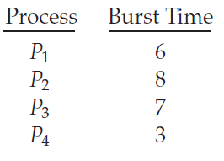
Using SJF scheduling, we would schedule these processes according to the following Gantt chart:
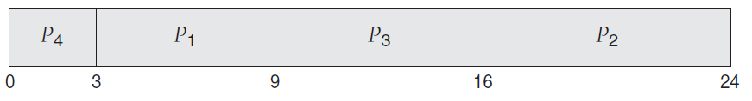

The waiting time is 3 milliseconds for process P1, 16 milliseconds for process P2, 9 milliseconds for process P3, and 0 milliseconds for process P4. Thus, the average waiting time is (3 + 16 + 9 + 0)/4 = 7 milliseconds. By comparison, if we were using the FCFS scheduling scheme, the average waiting time would be 10.25 milliseconds.
The SJF scheduling algorithm is provably optimal, in that it gives the minimum average waiting time for a given set of processes. Moving a short process before a long one decreases the waiting time of the short process more than it increases the waiting time of the long process. Consequently, the average waiting time decreases.
The SJF algorithm can be either preemptive or non-preemptive. The choice arises when a new process arrives at the ready queue while a previous process is still executing. The next CPU burst of the newly arrived process may be shorter than what is left of the currently executing process.
Preemptive SJF scheduling is sometimes called shortest-remaining-time-first scheduling.
As an example, consider the following four processes, with the length of the CPU burst given in milliseconds:
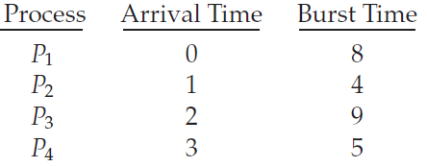
If the processes arrive at the ready queue at the times shown and need the indicated burst times, then the resulting preemptive SJF schedule is as depicted in the following Gantt chart:
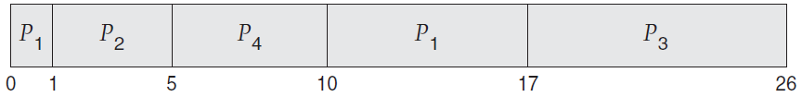
Process P1 is started at time 0, since it is the only process in the queue. Process P2 arrives at time 1. The remaining time for process P1 (7 milliseconds) is larger than the time required by process P2 (4 milliseconds), so process P1 is preempted, and process P2 is scheduled. The average waiting time for this example is [(10 − 1) + (1 − 1) + (17 − 2) + (5 − 3)]/4 = 26/4 = 6.5 milliseconds.
Non-preemptive SJF scheduling would result in an average waiting time of 7.75 milliseconds.

    - Priority Scheduling
The SJF algorithm is a special case of the general priority-scheduling algorithm. A priority is associated with each process, and the CPU is allocated to the process with the highest priority. Equal-priority processes are scheduled in FCFS order. An SJF algorithm is simply a priority algorithm where the priority (p) is the inverse of the (predicted) next CPU burst. The larger the CPU burst, the lower the priority, and vice versa.
Note that we discuss scheduling in terms of high priority and low priority. Some systems use low numbers to represent low priority; others use low numbers for high priority. This difference can lead to confusion. In this text, we assume that low numbers represent high priority.
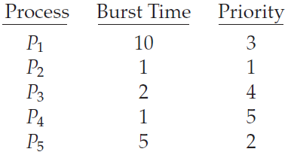
Using priority scheduling, we would schedule these processes according to the following Gantt chart:
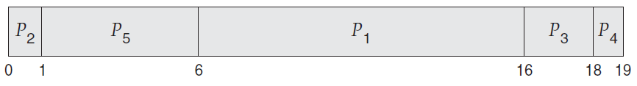
The average waiting time for this will be 6 for P1, 0 for P2, 16 for P3, 18 for P4 and 1 for P5. That is 6+0+16+18+1=41/5= 8.2 Miliseconds.

Priority scheduling can be either preemptive or non-preemptive. When a process arrives at the ready queue, its priority is compared with the priority of the currently running process. A preemptive priority scheduling algorithm will preempt the CPU if the priority of the newly arrived process is higher than the priority of the currently running process. A non-preemptive priority scheduling algorithm will simply put the new process at the head of the ready queue.
A major problem with priority scheduling algorithms is indefinite blocking, or starvation. A process that is ready to run but waiting for the CPU can be considered blocked. A priority scheduling algorithm can leave some low priority processes waiting indefinitely. In a heavily loaded computer system, a steady stream of higher-priority processes can prevent a low-priority process from ever getting the CPU. (Rumor has it that when they shut down the IBM 7094 at MIT in 1973, they found a low-priority process that had been submitted in 1967 and had not yet been run.)
A solution to the problem of indefinite blockage of low-priority processes is aging. Aging involves gradually increasing the priority of processes that wait in the system for a long time.
Aging involves gradually increasing the priority of processes that wait in the system for a long time. For example, if priorities range from 127 (low) to 0 (high), we could increase the priority of a waiting process by 1 every 15 minutes. Eventually, even a process with an initial priority of 127 would have the highest priority in the system and would be executed. In fact, it would take no more than 32 hours for a priority-127 process to age to a priority-0 process.

    - Round Robin (RR) Scheduling
Round Robin (RR)
The round-robin (RR) scheduling algorithm is designed especially for timesharing systems. It is similar to FCFS scheduling, but preemption is added to enable the system to switch between processes. A small unit of time, called a time quantum or time slice, is defined. A time quantum is generally from 10 to 100 milliseconds in length. The ready queue is treated as a circular queue. The CPU scheduler goes around the ready queue, allocating the CPU to each
process for a time interval of up to 1 time quantum.
To implement RR scheduling, we again treat the ready queue as a FIFO queue of processes. New processes are added to the tail of the ready queue.
The CPU scheduler picks the first process from the ready queue, sets a timer to interrupt after 1 time quantum, and dispatches the process.
One of two things will then happen. The process may have a CPU burst of less than 1 time quantum. In this case, the process itself will release the CPU voluntarily. The scheduler will then proceed to the next process in the ready queue. If the CPU burst of the currently running process is longer than 1 time quantum, the timer will go off and will cause an interrupt to the operating system. A context switch will be executed, and the process will be put at the tail of the ready queue. The CPU scheduler will then select the next process in the ready queue.
The average waiting time under the RR policy is often long.
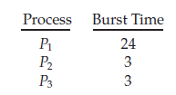
If we use a time quantum of 4 milliseconds, then process P1 gets the first 4 milliseconds. Since it requires another 20 milliseconds, it is preempted after the first time quantum, and the CPU is given to the next process in the queue, process P2. Process P2 does not need 4 milliseconds, so it quits before its time quantum expires. The CPU is then given to the next process, process P3. Once each process has received 1 time quantum, the CPU is returned to process P1 for an additional time quantum. The resulting RR schedule is as follows:
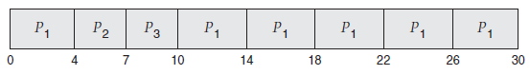
Let’s calculate the average waiting time for this schedule. P1 waits for 6 milliseconds (10 - 4), P2 waits for 4 milliseconds, and P3 waits for 7 milliseconds.
Thus, the average waiting time is 17/3 = 5.66 milliseconds.
The performance of the RR algorithm depends heavily on the size of the time quantum. At one extreme, if the time quantum is extremely large, the RR policy is the same as the FCFS policy. In contrast, if the time quantum is extremely small (say, 1 millisecond), the RR approach can result in a large number of context switches.

  - Algorithm Evaluation
How do we select a CPU-scheduling algorithm for a particular system? As we have discussed in the previous section, there are many scheduling algorithms, each with its own parameters. As a result, selecting an algorithm can be difficult. We next describe the various evaluation methods we can use.

    - Deterministic Model
One major class of evaluation methods is analytic evaluation. Analytic evaluation uses the given algorithm and the system workload to produce a formula or number to evaluate the performance of the algorithm for that workload.
Deterministic modeling is one type of analytic evaluation. This method takes a particular predetermined workload and defines the performance of each algorithm for that workload. For example, assume that we have the workload shown below. All five processes arrive at time 0, in the order given, with the length of the CPU burst given in milliseconds:
Consider the FCFS, SJF, and RR (quantum = 10 milliseconds) scheduling algorithms for this set of processes. Which algorithm would give the minimum average waiting time?
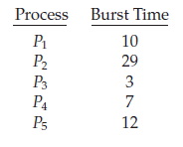
For the FCFS algorithm, we would execute the processes as
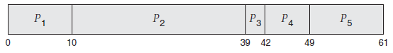
Thus, the average waiting time is (0 + 10 + 39 + 42 + 49)/5 = 28 milliseconds.

With non-preemptive SJF scheduling, we execute the processes as
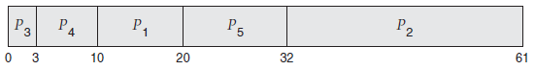
The waiting time is 10 milliseconds for process P1, 32 milliseconds for process P2, 0 milliseconds for process P3, 3 milliseconds for process P4, and 20 milliseconds for process P5. Thus, the average waiting time is (10 + 32 + 0 + 3 + 20)/5 = 13 milliseconds.

With the RR algorithm, we execute the processes as
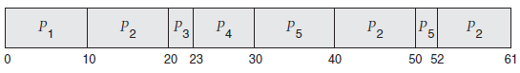
The waiting time is 0 milliseconds for process P1, 32 milliseconds for process P2, 20 milliseconds for process P3, 23 milliseconds for process P4, and 40 milliseconds for process P5. Thus, the average waiting time is (0 + 32 + 20 + 23 + 40)/5 = 23 milliseconds.
We can see that, in this case, the average waiting time obtained with the SJF policy is less than half that obtained with FCFS scheduling; the RR algorithm gives us an intermediate value.
Deterministic modeling is simple and fast. It gives us exact numbers, allowing us to compare the algorithms. However, it requires exact numbers for input, and its answers apply only to those cases. The main uses of deterministic modeling are in describing scheduling algorithms and providing examples.
    - Queuing Model
On many systems, the processes that are run vary from day to day, so there is no static set of processes (or times) to use for deterministic modeling. What can be determined, however, is the distribution of CPU and I/O bursts. These distributions can be measured and then approximated or simply estimated.
Queuing analysis can be useful in comparing scheduling algorithms, but it also has limitations. At the moment, the classes of algorithms and distributions that can be handled are fairly limited.
As a result of these difficulties, queuing models are often only approximations of real systems, and the accuracy of the computed results may be questionable.

    - Simulation

detqu
To get a more accurate evaluation of scheduling algorithms, we can use simulations. Running simulations involves programming a model of the computer system. Software data structures represent the major components of the system. The simulator has a variable representing a clock. As this variable’s value is increased, the simulator modifies the system state to reflect the activities of the devices, the processes, and the scheduler. As the simulation executes, statistics that indicate algorithm performance are gathered and printed.
Simulations can be expensive, often requiring hours of computer time. A more detailed simulation provides more accurate results, but it also takes more computer time. In addition, trace tapes can require large amounts of storage space. Finally, the design, coding, and debugging of the simulator can be a major task.

    - Implementation
Even a simulation is of limited accuracy. The only completely accurate way to evaluate a scheduling algorithm is to code it up, put it in the operating system, and see how it works. This approach puts the actual algorithm in the real system for evaluation under real operating conditions.
The major difficulty with this approach is the high cost. The expense is incurred not only in coding the algorithm and modifying the operating system to support it (along with its required data structures) but also in the reaction of the users to a constantly changing operating system.

  - Self-test Questions

- Explain four criteria for selecting a scheduling algorithm.
- What is the challenge with the FCFS algorithm?
- Discuss three algorithm evaluation methods.

  - Summary

CPU scheduling is the task of selecting a waiting process from the ready queue and allocating the CPU to it. The CPU is allocated to the selected process by the dispatcher.
The wide variety of scheduling algorithms demands that we have methods to select among algorithms. Analytic methods use mathematical analysis to determine the performance of an algorithm. Simulation methods determine performance by imitating the scheduling algorithm on a “representative” sample of processes and computing the resulting performance. However, simulation can at best provide an approximation of actual system performance. The only reliable technique for evaluating a scheduling algorithm is to implement the algorithm on an actual system and monitor its performance in a “real-world” environment.
  - Reference

- William, S. (2017). Operating Systems: Internals and Design Principles (9th ed.). Pearson ISBN– 10: 0134670957

